Production Module

Main Database
Opening Quantity
Material Usage
Closing Balance
Calibration Chart
Item

Main Transactions
Receipt
Production
Issue
Transfer
Receipt Return

Production Return

Issue Return

Transfer Return

Table of Contents

Requirements Analysis
Systems Characteristics
Relationship to other Modules
User Pre-Requisites
Getting Started
Setups
- Area File ......................................................................................................
- Department File …………………………………………………………………………………………
- Item File …………………………………………………………………………………………………..
- Opening Quantity Balance File ………………………………………………………………… …
- Closing Schedule File …………………………………………………………………………………
- Calibration Chart File …………………………………………………………………………………
- Material Usage File ……………………………………………………………………………………
- Customer Closing Balance File ……………………………………………………………………
Transactions
- Receipt: Receiving Items from Suppliers in Production Areas …………………………..
- Receipt Return: Returning Items to Suppliers in Production Areas…………………….
- Production: Recording Items Production in Areas ……………………………………………
- Production Return: Returning Products to Areas ……………………………………………
- Departmental Transfer: Recording Transfer of Items from One Area to Another .
- Issue: Recording of Items Issuance to Areas as per Products …………………………
- Issue Return: Recording of Items Issuance to Areas as per Products ……………….
- Adjustments: Adjusting Items Issuance to Areas as per Products …………………….
Reports
- Area Listing ……………………………………………………………………………………………….
- Department Listing …………………………………………………………………………………….
- Stock Directory…………………………………………………………………………………………..
- Stock Opening Balances………………………………………………………………………………
- Calibration Chart…………………………………………………………………………………………
- Standard Material Usage……………………………………………………………………………..
- Transaction Logs………………………………………………………………………………………..
- Items Ledger……………………………………………………………………………………………..
- Items Trial Balance…………………………………………………………………………………….
- Consumption Reports…………………………………………………………………………………
- Variance Reports……………………………………………………………………………………….
- Item Confliction with Reports……………………………………………………………………..
- Missing Standards of Finished Goods…………………………………………………………..
- Enquiry for Standard Usage per Ton……………………………………………………………
- UPL Reports………………………………………………………………………………………………
Utility Tools
- Auditing Process……………………………………………………………………………………………
- Posting Process ……………………………………………………………………………………………
- Un-Posting Process…………………………………………………………………………………………

Requirements Analysis
Systems Characteristics
Integration with Other Modules

Production Module is not linked with any FCL module. It is an stand-alone application.
[moretosay] about items
User Pre-Requisites
Getting Started

Setup
_______________________________________________________________________________

Setup files are data entry screens for the following database entities of the production module:

- Area
- Department
- Item
- Opening Quantity Balance
- Monthly Closing Schedules
- Calibration Chart
- Material Usage recipes
- Customer Closing Balance

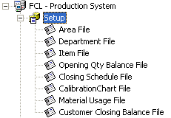 | 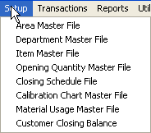

In the subsequent pages, each Setup entry is described briefly with the help of screen-shots.
Area File
_______________________________________________________________________________

Description
A simple Code-Name data entry form for keeping record of different areas in production stages.

Note that:
- Areas vary with respect to the production store module; e.g. for UPL Processing Store, there are different areas from those of UPL Packing and FCL- Auxiliary Stores modules. This is pre-defined in the system database; by ‘delete and/or add’ operations on each store’s Area Setup entry form, this area-list can be changed

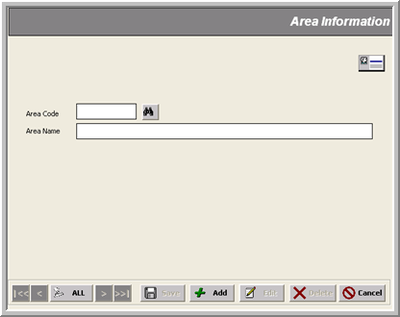
* Area Description (@³⁰)

* Area Code (@@)

Department File
_______________________________________________________________________________

Description
A simple Code-Name data entry form for keeping record of different departments of processing stores. Each department identifies the customers whose products are processed. For example
UPL Reprocessing department is dedicated for Unilever Private Limited.

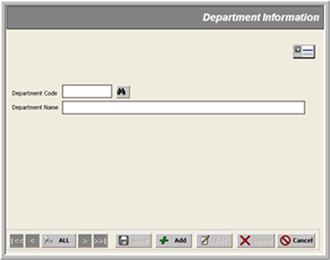
* Department Description (@³⁰)
* Department Code (@@@@)

Item File
_______________________________________________________________________________

Description
This form is used for entering data about different raw materials, finished or semi-finished products with the following information:
- U/I : Unit of measurement used for the item
- Active %: Purity of solid contents
- Wastage %: Standard wastage allowance. i.e. the quantity of material allowed to be wasted during processing
- Customer Code: Supplier’s reference used for the item

Note that:
- There is a particular coding convention used for all kinds of items, for example:
- Items with code starting in 01, 02, …,500000 are Raw Materials
- Items with code starting in 50… are Semi-Finished Products
- Items with code starting in 60… are Finished Products
- Items also vary with respect to the production store module; e.g. for UPL Processing Store, there are different items from those of UPL Packing and FCL- Auxiliary Stores modules. This is pre-defined in the system database; by ‘delete and/or add’ operations on each store’s Item Setup entry form, this item-list can be changed

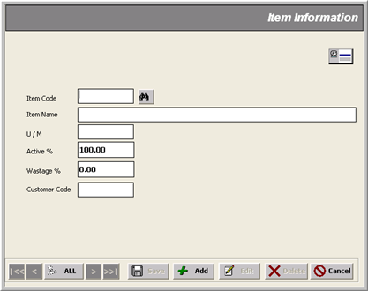
Unit of Measurement (@⁴)
*Item Code (@⁶)
* Item Name (@⁴⁰)
Active % (#^{n})
Wastage %(#^{n})

Customer Code(@¹⁰)

Opening Quantity Balance File
_______________________________________________________________________________

Description
This form is used for entering opening balances of different items’ quantities in each production areas.

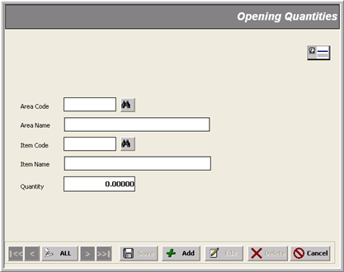
* Area Code
* Item Code
Opening Quantity (#^{n})

Closing Schedule File
_______________________________________________________________________________

Description
This form is used to define closing schedules of customers for different months.

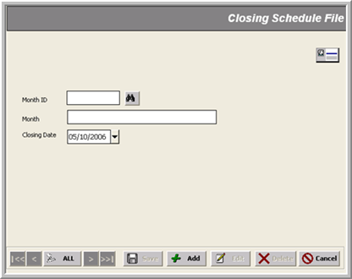
* Monthly Period ID (##-####)
* Closing Date
Calibration Chart File
_______________________________________________________________________________

Description
This form is used to specify the quantities of different items in all tanks with respect to level
(in feet and inches) as well as weight. Once specified here, this chart is then used for finding weights for any level of quantities in feet and/or inches.

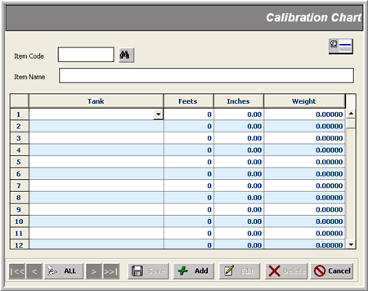
* Item Code
* Tank
Inches
Feets
Weight
Material Usage File
_______________________________________________________________________________

Description
This form is used to specify the quantities of different items used in manufacturing a particular quantity of product.

Note that:
- This recipe is maintained by a date called Effective Date (since the recipe was taken in effect), so there may be more than one ‘usage formulation’ for a product with different dates.
For example,
As of 10/05/2006, 1000 Kg of Paste is produced with:
400 kg of 010002- Aime Perfume
600 kg of 010001- Acid Blue 31 CI
But on 12/07/2006, this recipe was changed and then for producing 1000 Kg of Paste
raw materials items required were:
200 kg of 010002- Aime Perfume
800 kg of 010001- Acid Blue 31 CI

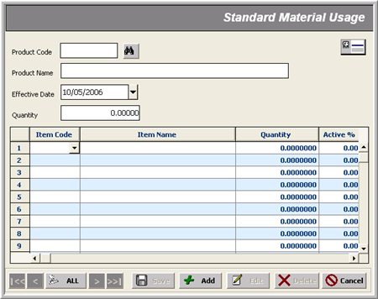
* Product Code
* Effective Date
*Item Quantity
* Item Code
Active
* Product Quantity

Customer Closing Balance File
_______________________________________________________________________________

Description
This form is used to record balance quantities of different items for a particular customer e.g. UPL Reprocessing, FC Stores, AVS Reprocessing, etc.

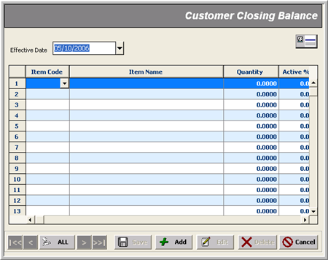
* Effective Date
* Item Code
Active
Quantity

Transactions
_______________________________________________________________________________

In all transaction entries (e.g. Receipt, Production, Transfer, Issue and Adjustment), we specify quantities of items in different areas received, produced, returned, transferred from/to or issued as explained in the next sections.

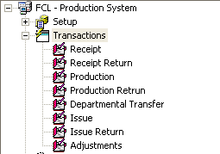 | 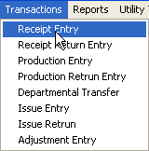

Receipt/Receipt Return Transactions _______________________________________________________________________________
Use case: Recording Receipt or Return of Items from/to Suppliers

Description
This form is used to record items’ receipts from suppliers OR return of rejected materials to the suppliers, at different production areas with the following data entry:

- Transaction Date
- Shift (when transaction recording was made)
- One or more items with Area, Supplier, Quantity and Active % information.
A reference no. can optionally be provided in Ref#.

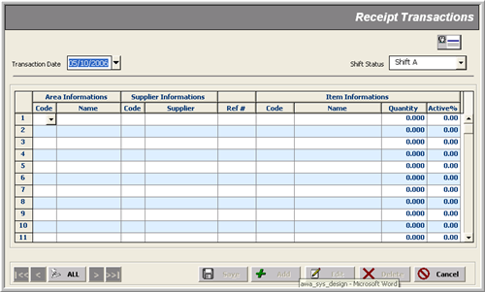
* Transaction Date
* Area
* Item
Supplier
* Shift
Quantity
Active
Ref #

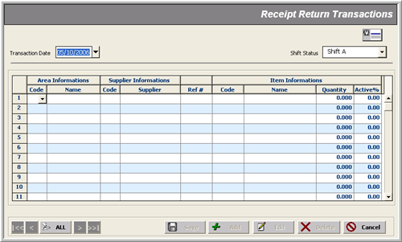
* Transaction Date
* Area
* Item
* Item
Supplier
* Shift
Active
Ref #
Quantity
Production/Production Return Transactions _______________________________________________________________________________
USE CASE: Recording Items Production in Areas

Description
This form is used to record items’ production at different areas with the following data entry:

- Transaction date
- Shift (when transaction recording was made)
- One or more items with Area, Quantity and Active % information.
A reference no. can optionally be provided in Ref#.

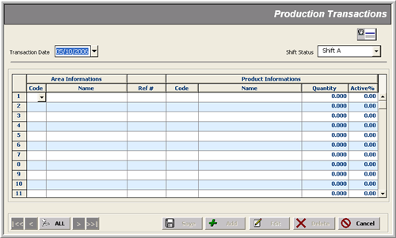
* Transaction Date
* Area
* Product Item
* Shift
* Quantity
Active
Ref #

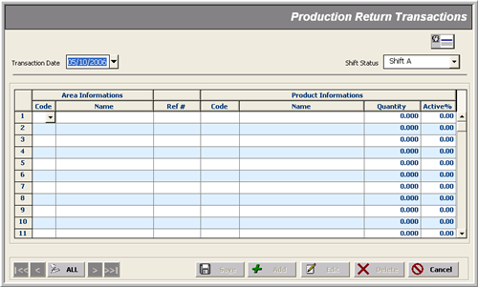
* Transaction Date
* Area
* Shift
* Quantity
Active
Ref #
*Product Item

Note that:
- Production Return transaction is used to record products returns to different production areas for any of these two reasons:
- In case of wrong entry in Production Transaction, we cancel that effect here
- When the product is not made up to the standard, it is then returned back from here

Departmental Transfer Transaction _______________________________________________________________________________
Use case: Recording Transfer of Items from One Area to Another

Description
This form is used to record transfer of items at different production areas with the following data entry:

- Transaction date
- Shift (when transaction recording was made)
- One or more items with Areas (Sending & Receiving), Quantity and Active % information.
This updates the balance quantities of items in the respective areas.

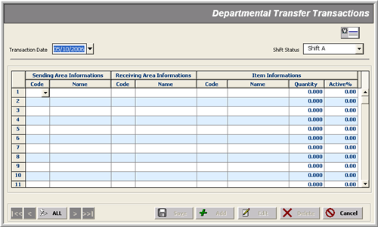
* Transaction Date
* Sending Area
* Item
* Shift
Quantity
Active
* Receiving Area
Issue/Issue Return Transactions _______________________________________________________________________________
Use case: Recording of Items Closing Balances in Areas

Description
This form is used to record items’ issuance/usage in the specified areas for different products with the following data entry:

- Transaction date
- Shift (when transaction recording was made)
- One or more items with Areas, Product, Closing & Issue (Quantities) information.
- W/O (i.e. items without product) and I/P (items in process)
Note that:
- W/O check specifies whether the corresponding item is issued with product or not. The default is ‘with’ product in which case the product code must be provided. When checked, this option makes product selection invalid meaning that ‘no need to specify product when the item is issued without product’
- I/P check is a kind of provision to specify whether or not the item is ‘in process of production’. If it is checked, it will have the following effects:
- this item will not be listed in the consumption report, because it was not actually consumed, rather it is in the process of consumption
- when the production is complete, this item will be marked as ‘consumed’ with the date and shift of that time
- In case of wrong entry in Issue Transaction, Issue Return Transaction form is used to cancel out its effect by recording a contra entry against the same product items with the same data entry; again,
W/O check specifies whether the corresponding item was issued with product or not. When checked, it means that ‘no need to specify product as the item was issued without product’

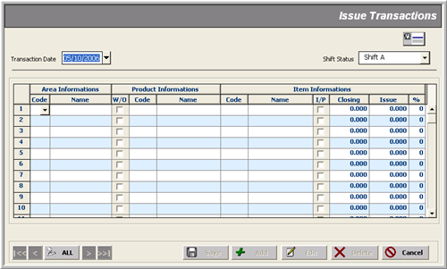
* Transaction Date
* Area
In Process

* Product
* Shift
Item’s Closing Qty
Issue Qty
* Item
Without Wastage
%

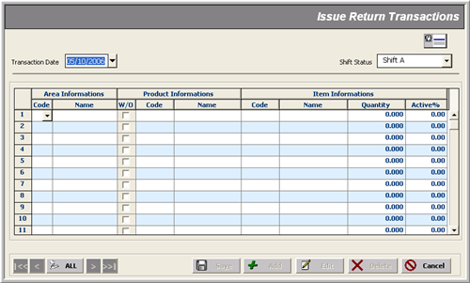
* Transaction Date
* Area
* Product
* Shift
Quantity
Active %
* Item
Without Wastage
Adjustments Transaction _______________________________________________________________________________
Use Case: Adjusting Items’ Issuance to Areas as per Products

Description
This form is used to record ‘adjustment’ of items issued/returned to/from areas for different products with the following data entry:

- Transaction date
- Shift (when transaction recording was made)
- One or more items with Areas, Product, Quantity and Active % information.

Note that:
- Adjustment entries are there to ‘adjust’ the quantities of items issued or returned more or less than actual; so their sole purpose is merely to correct invalid data entry made in Issue Transactions and Issue Return Transactions

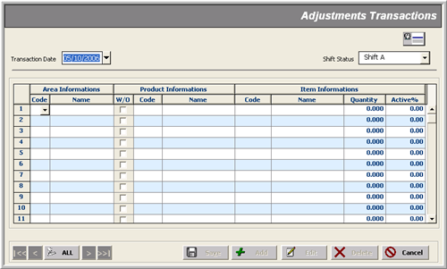
* Transaction Date
* Area
* Product
* Shift
Quantity
Active %
* Item
Without Wastage
Reports
_______________________________________________________________________________

The Production module reports can be divided in three categories:

- Setup Reports
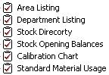
- Transaction Activities Reports
- Financial Reports
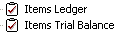
- Utility Reports
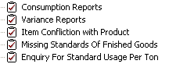
- UPL Reports

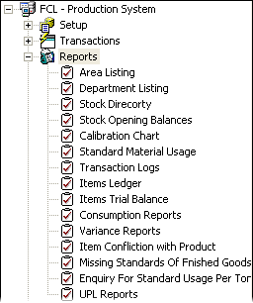 | 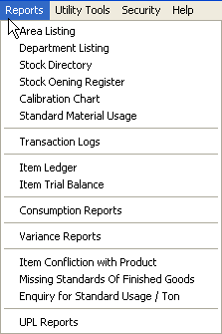

If you have become familiar with the tools and controls of report generation, let’s look at the Production Module reports one by one, focusing on the parameter selections and report formats available.

Note that if you don’t specify codes in textboxes, each report can be viewed with default parameters setting (empty code fields imply ‘all’) as the following label reads:

So, there is nothing mandatory in all report parameter forms. Combo boxes already hold one possible selection as default.

Utility Tools
_______________________________________________________________________________

Utility Tools cover periodic processes within a closing schedule life-cycle, such as:

- Auditing
- Posting Transactions
- Un-Posting Transactions
- Backing up/Restoring Database

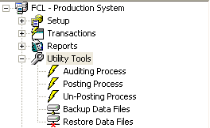 | 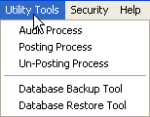

Auditing Process _______________________________________________________________________________

Description
Auditing Process is performed to trace out buggy transaction activities.

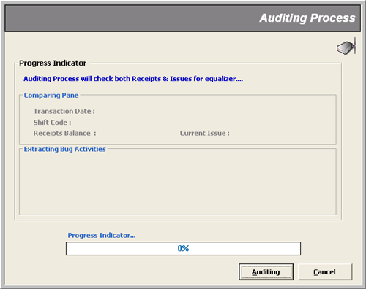
When is clicked, the following window appears indicating the start of Auditing Process.

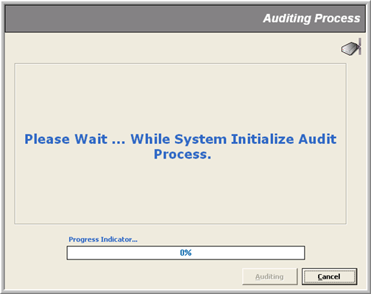

Next window shows that the Auditing Process is checking through transaction activities for possible bugs.
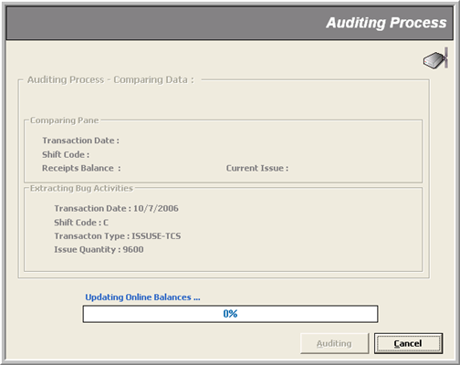
On successful check, a message box pops up saying ‘System did not found any Exception’.

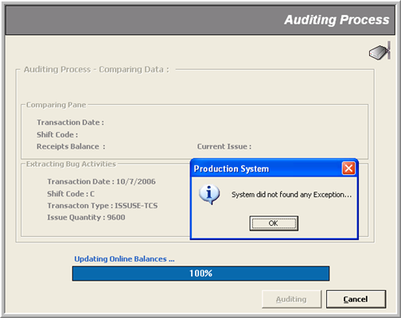s
Posting Process _______________________________________________________________________________

Description
Posting Process is performed to Post transactions in non-editable mode to tag them as ‘confirmed’ transactions. Posting Process is followed by Auditing Process.

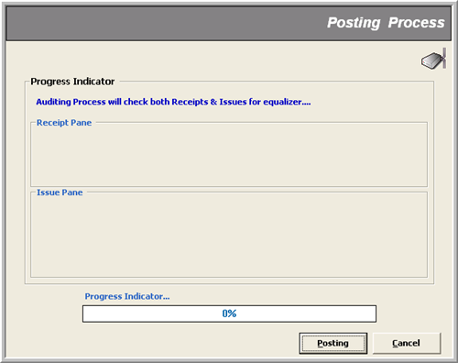

On finding un-posted data, a message box pops up asking for confirmation to go on.
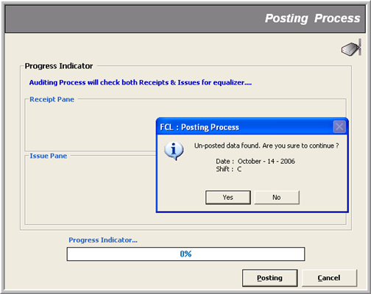

Next window shows the scan progress for un-posted transactions.

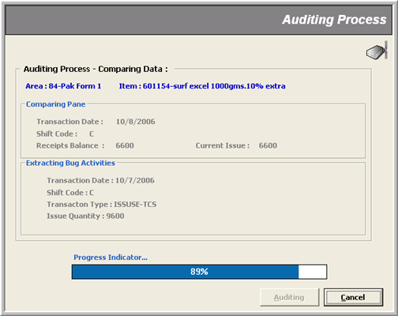

Finally, a message box flags the end of process.

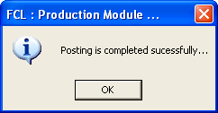

Un-Posting Process _______________________________________________________________________________

Description
Un-posting Process is performed to revert the Post transactions (with the specified date and shift parameters) back in editable mode.

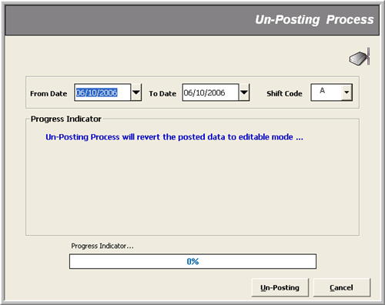

When there is no posted data found, a message box informs as such.

